

American International University-Bangladesh (AIUB)  
**Department of Computer Science  
Faculty of Science &Technology (FST)  
Summer 20_21  
CSC 2210 Object Oriented Analysis and Design (OOAD)**

**Section: G  
Group No: 02**

**PROJECT TITLE : Restaurant’s Point of Sale System Management**

An Object-Oriented Analysis and Design (OOAD) project submitted

By

|  |  |  |
| --- | --- | --- |
| SN | Student Name | Student ID |
| 04 | SHAON, INDROJIT DHE | 18-38674-3 |
| 05 | PRANTO SAHA | 18-38805-3 |
| 06 | ABEDIN, MOHAMMAD ADNAN | 18-38821-3 |
| 10 | NABAJIT DEY | 19-40618-1 |
| 20 | TUNE, RIFAH NANZIBA | 20-42384-1 |

The project will be Evaluated for the following Course Outcomes

|  |  |
| --- | --- |
| **CO3:** Formulate a baseline document to perform feasibility study of a proposed project idea | Total Marks |
|  |
| Project Background Analysis [5Marks] |  |
| Project Feasibility Study [5Marks] |  |
| Project Content Knowledge (e.g., diagram scenario narration) [5Marks] |  |
|  | |
| **CO4:** Design a Complex engineering problem using UML Tools and explain the system using a project report and presentation | Total Marks |
|  |
| Completeness, Correctness, and Diagram Standard Tools [5Marks] |  |
| Report Organization [5Marks] |  |
| Submission and Presentation Delivery [5Marks] |  |

# CO3

# Project Title: Restaurant’s Point of Sale System Management

**Project Overview:**

Restaurant’s point of sale System management is a versatile platform that integrates the actions of multiple users and helps to manage resources accordingly. The implementations of a point of sale system in a restaurant enables ease of managing orders, handling transactions, keeping track of resources and generate necessary statistics required for business.

One of the key benefits of a point of sale system is the real-time handling of data. For example, if a customer chooses to add items to an order; thereafter changing his/her mind and revising that order, it is possible to instantaneously change it.

Another benefit of a point of sale system is that it simplifies communications between the kitchen and the wait staff. Orders go through the computer, directly to the kitchen printer. Another benefit of a restaurant point of sale program is that it can track everything from food usage to the most popular menu items. Because the point of sale system acts as a time clock, it can also help prepare payroll. This can save you a lot of money in your bookkeeping department. Along with the daily operations of running a restaurant, a point of sale system can organize profit and loss statement and sales tax.

Sales statistics and resource management are important factors to keep track of in any business. If a business is aimed to grow ergonomically, the presence of a point of sale system largely benefits to achieve it. The simplicity of functionality is also suitable for users with little to no experience with complex technology. This means they can focus more on tasks at hand while the system works spontaneously.

Management is the key to handle tasks and organize business. A point of sale system can be largely beneficial by providing instantaneous data to managers who can use it to handle the workload, direct tasks to employees and arrange required resources corresponding to the inventory.

With the above stated benefits, this project was undertaken to develop a simple yet robust system that can aid the development of a restaurant business.

**Justification:**

The justification of implementing a point of sale system in a restaurant business is stated below corresponding to the user groups:

**Customers:**

a. Placing an order quick: Customers can take a look at the menu and choose their desired items easily. This aids in long lines at restaurants.

b. Revising placed orders: If there is any change in mind, a customer can add/remove from their orders prior to confirming.

c. Receiving detailed bills: In the event of a mishap (not receiving ordered food, unsatisfactory quality of food or service of employees), a customer can show his/her bill with all the details of the order and responsible employee to claim their rights.

d. Organized method to save time: Fast management of orders using tokens means serving more people in less time. This helps a customer spend less time rather than waiting for long periods of time to receive their food.

e. Availing customer benefits: A point of sale system can fetch data from its database to find a frequent customer or someone who has placed a large order. Then, the business can honor the customer with benefits based on their terms and conditions of business.

**Employees:**

a. Handling orders: Employees can take orders in a short span of time. They can also change the order befitting the customer’s wish.

b. Managing bulk orders: During rush hours, employees can rely on a point of sale system to handle large quantities of orders to avoid lagging in task handling.

c. Avoiding hassle: Employees can avoid dealing with customers directly in the event where a rude customer might make baseless complaints or deny payment. The presence of an automated system can aid in providing real-time information of the customer’s orders to the authority.

d. Boost performance: Ease of task management means saving both time and energy. This can significantly boost performance and increase the chances of achieving employee benefits.

**Managers:**

a. Instant response: Manager can readily view any required information from the POS system and take action accordingly.

b. Inventory management: A point of sale system can keep the manager updated regarding available resources for business. The manager can update the inventory to keep the business running.

c. Sales management: Manager can view sales statistics corresponding to any time span and prepare reports to aid in taking important actions required for business growth and sustainability.

**CO4**

**Project’s use case diagram :**

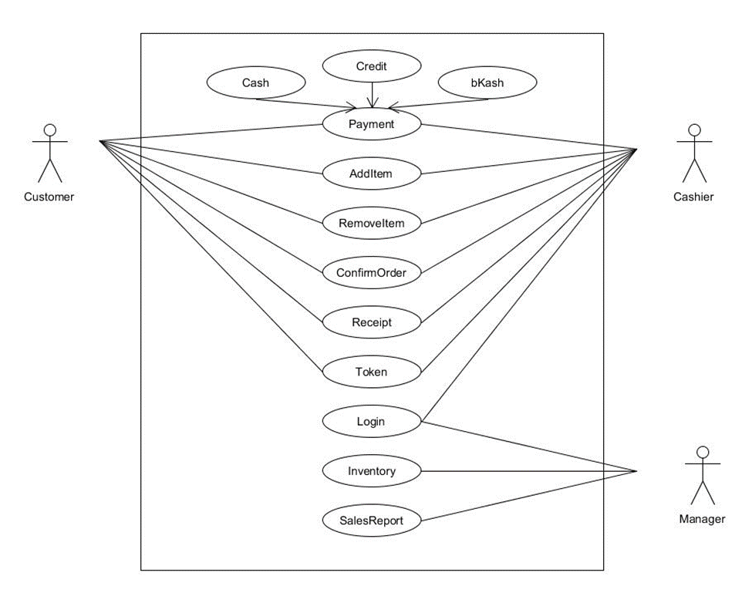

**Conclusion:**

The project is simple yet effective and essential in a restaurant environment. There are further scopes of upgrading and altering this system. Cases such as changes of management, employees or users can lead to the necessity of customization. Thereafter, the system can be changed according to requirements.